



Guide for building the ultimate Qt package for Ida Pro.

By Storm Shadow.

Content

* 1. Why is it needed?
  2. Prerequisites Software.
  3. Prerequisites Environment.
  4. Building windows QT.
  5. Building QScintilla2.
  6. Building Sip.
  7. Building PyQt.
  8. Building QScintilla2 for PyQt4.
  9. Wrapping it all.
  10. Testing.

Why is it needed?

Well the official PyQt4 package is built as a minimalistic build.

Its main purpose is only for basic PyQt functions for Ida Pro.Even then the official hex-ray package lacks basic functions, that the prebuild official have. If you want to develop really extended and fun Qt apps here is how to do it.

Prerequisites Software.

Software needed.

(Hold ctrl and press links)

Python latest build

Remember only install x86, and not x86-64

Link [python2.](https://www.python.org/downloads/release/python-2710/)

Strawberry-perl.

Latest.

Link [Strawberry Perl](https://code.google.com/p/strawberry-perl/downloads/list)

Visual Studio 2010

We only use 2010 and only this version, more of why later)

Visual Studio 2010 Service Pack 1

Windows SDK v7.0

[Link Windows sdk](http://www.microsoft.com/en-us/download/details.aspx?id=3138)

Cmake

Not really needed but install it anyway.

[Link CMake latest](http://www.cmake.org/cmake/resources/software.html)

git for windows

[Link Git for Windows](http://git-scm.com/download/win)

gnuwin32

[Link gnuwin32](http://git-scm.com/download/win)

Hex-Rays

[Link To Hex-ray Site](https://www.hex-rays.com/index.shtml)

Prerequisites Environment.

We want the best development environment, so we don’t hit trouble when we start building.

First Python.

Cmd prompt and command to open the system variable environment settings.

Microsoft Windows [Version 10.0.10240]

(c) 2015 Microsoft Corporation. Med enerett.

C:\Users\Storm Shadow>control.exe sysdm.cpl,System,3

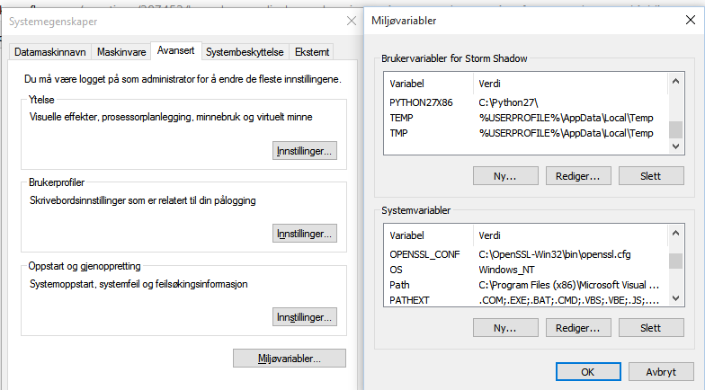

In the system variable settings, we make these new variables.

PYTHONHOME

C:\Python27

PYTHONSCRIPT

C:\Python27\Scripts

LIB

C:\Python27\Libs; C:\Qt\4.8.7\lib; C:\Program Files (x86)\Microsoft SDKs\Windows\v7.1A\lib

INCLUDE

C:\Python27\include; C:\Program Files (x86)\Microsoft SDKs\Windows\v7.1A\Include;C:\Qt\4.8.7\include

QTDIR

C:\Qt\4.8.7\bin

QMAKESPEC

C:\Qt\4.8.7\mkspecs\win32-msvc2010

QT_NAMESPACE

QT

We then add most off them to the PATH, so we are sure they are found.

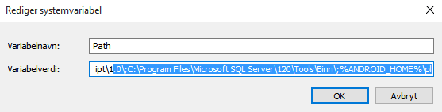

Open path and

Add the line to the end of path

;%PYTHONHOME%;%PYTHONSCRIPT%;%LIB%;%INCLUDE%;%QTDIR%;%QMAKESPEC%;%QT_NAMESPACE%

Test if everything is working.

Open CMD

Python

C:\Users\Storm Shadow>python

Python 2.7.10 (default, May 23 2015, 09:40:32) [MSC v.1500 32 bit (Intel)] on win32

Type "help", "copyright", "credits" or "license" for more information.

>>>

Qmake

C:\Users\Storm Shadow>qmake -v

QMake version 2.01a

Using Qt version 4.8.7 in C:\Qt\4.8.7\lib

Looks we are ready to start.

Building windows QT.

Important!

We have to build with visual studio 2010 since Ida pro Gui is built with that version. We would get Runtime errors when using PyQt when we start using the more advance functions.

Download [Link Latest Qt4](http://download.qt.io/official_releases/qt/4.8/4.8.7/) and install

qt-opensource-windows-x86-vs2010-4.8.7.exe It have to be a 4.8.x version Qt5 wont work.

We open up Visual studio 2010 x86 cmd Prompt.

We then goto Qt root folder in prompt.

C:\Qt\4.8.7>

Then we configure Qt with namespace QT, Ida pro have to have this.  
We also make sure the whole package is build so we specify those. Sometimes the build jumps over if we don’t specify.

Also very important is we specify that we want to use vs 2010 and that Runtime. You have to do this!

Configure command

C:\Qt\4.8.7>configure.exe -qtnamespace QT -platform win32-msvc2010 -release -opensource -opengl desktop -no-qt3support -phonon -webkit -scripttools -script -audio-backend -declarative -nomake demos -nomake examples

We say yes to the license.  
  
Now this takes a couple of minutes but we can check what it will build.

If you pause in the beginning you can see what it does

Here is a pastie. Notice the yes and no on the list.  
<http://pastebin.com/VRn2ppmU>

After it is finished we start building it.There are in other tuts Jom for Qt for faster building.But this can jump over the option -platform win32-msvc2010.  
So we use

C:\Qt\4.8.7>nmake

This takes like at least 20 cups of coffee.

Depending on your pc it can take 1 to 3 hours.

when it is all done we type.

C:\Qt\4.8.7>nmake install.

Building QScintilla2

What is QScintilla2, well it’s a code library for Qt and it is in the prebuild Qt package also.  
Useful for any type of code output. Why in the world hex-ray didn’t add this to their package, must be unawareness.  
Download from Riverbank last stable windows source.  
<https://www.riverbankcomputing.com/software/qscintilla/download>

Extract and in vs 2010 prompt goto the

D:\QScintilla-gpl-2.9\Qt4Qt5

Then configure with qmake and specify platform target to be sure.

D:\QScintilla-gpl-2.9\Qt4Qt5>qmake -spec win32-msvc2010 qscintilla.pro

Then nmake

Then nmake install

Even with install it properly can have not done it so we.

Go to the release folder.

Copy qscintilla2.dll to C:\Qt\4.8.7\Bin

Copy qscintilla2.lib to C:\Qt\4.8.7\Lib

Copy qscintilla2.dll to C:\Qt\4.8.7\Lib

We then goto the

D:\QScintilla-gpl-2.9\designer-Qt4Qt5

And do the same.  
D:\QScintilla-gpl-2.9\designer-Qt4Qt5>qmake -spec win32-msvc2010 designer.pro

Then nmake

Then nmake install

We make sure it was correct installed.Go to Release folder.

Copy qscintillaplugin.dll, qscintillaplugin.lib,qscintillaplugin.exp to C:\Qt\4.8.7\plugins\designer

Building Sip

Sip is a binding for PyQt and windows Qt.

We need to build this.

Download from riverbank.  
Latest stable windows source.

<https://www.riverbankcomputing.com/software/sip/download>

Extract and open Root folder in vs 2010 prompt.  
Also here we are sure to add what platform we are using.

D:\sip-4.16.9>Configure.py -p win32-msvc2010 --platform=win32-msvc2010

This is SIP 4.16.9 for Python 2.7.10 on win32.

The SIP code generator will be installed in C:\Python27.

The sip module will be installed in C:\Python27\Lib\site-packages.

The sip.h header file will be installed in C:\Python27\include.

The default directory to install .sip files in is C:\Python27\sip.

D:\sip-4.16.9>

Then nmake

Then nmake install

7. Building PyQt

Now we are ready for building the actually PyQt4.  
Download from Riverbank.

Latest stable windows source.  
<https://www.riverbankcomputing.com/software/pyqt/download>

Extract and go to Root Folder.

There are two configure files one called configure.py(that’s for PyQt5)  
We want use the configure-ng.py.  
Again we make sure correct runtime is selected in build. Also the prebuild PyQt is build with vs 2008.  
So if we skip the option it would automatic go to lowest vs version you have installed. We don’t want that.

Also we add the Qscilla2 API we build previously.

We configure and say yes to the license.

D:\PyQt-win-gpl-4.11.4>Configure-ng.py --spec=win32-msvc2010 -a --qsci-api

Also in PyQt we check what is build for us.  
<http://pastebin.com/L0zGb6VN>

Check if Qscilla2 API and all the modules look similar to my output.

Then nmake

Then nmake install

Now in windows go to folder C:\Python27\Lib\site-packages\PyQt4

It should look like this

Except the Qsci.pyd(we will build that next.)

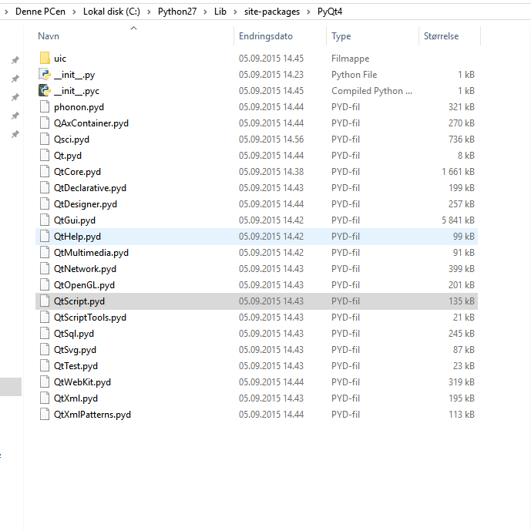

Building QScintilla2 for PyQt4

We go back to QScintilla package folder we download before.

Got the python folder D:\QScintilla-gpl-2.9\Python

We configure once again and make sure to specify target.  
D:\QScintilla-gpl-2.9\Python>Configure.py --spec=win32-msvc2010

Then nmake

Then nmake install

We can check in C:\Python27\Lib\site-packages\PyQt4 folder if Qsci.pyd showed up.

Like previous picture.

Wrapping it all.

We want to make a full dev PyQt package we can use and develop with.

We start with going to C:\QT\4.8.7\Bin  
copy and paste all *.exe and *.lib from Bin folder to

C:\Python27\Lib\site-packages\PyQt4 folder.

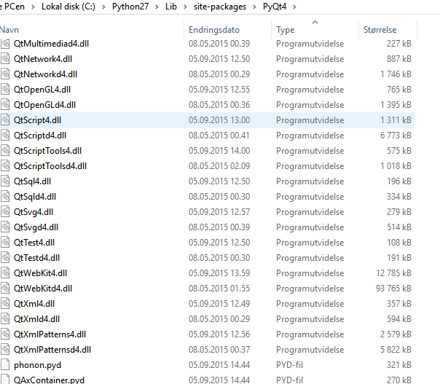

Then copy these folders from C:\QT\4.8.7\  
And paste into C:\Python27\Lib\site-packages\PyQt4

config.profiles to C:\Python27\Lib\site-packages\PyQt4

import to C:\Python27\Lib\site-packages\PyQt4

mkspecs to C:\Python27\Lib\site-packages\PyQt4

qsci folder to C:\Python27\Lib\site-packages\PyQt4

from C:\Qt\4.8.7\plugins copy designer to C:\Python27\Lib\site-packages\PyQt4

then from the PyQt folder we downloaded from river bank.  
Then copy these folders from root and paste into C:\Python27\Lib\site-packages\PyQt4

examples to C:\Python27\Lib\site-packages\PyQt4

doc to C:\Python27\Lib\site-packages\PyQt4

examples to C:\Python27\Lib\site-packages\PyQt4

sip to C:\Python27\Lib\site-packages\PyQt4

from designer\release copy pyqt4.lib, pyqt.dll to   
C:\Python27\Lib\site-packages\PyQt4\designer.  
It should look similar to this.

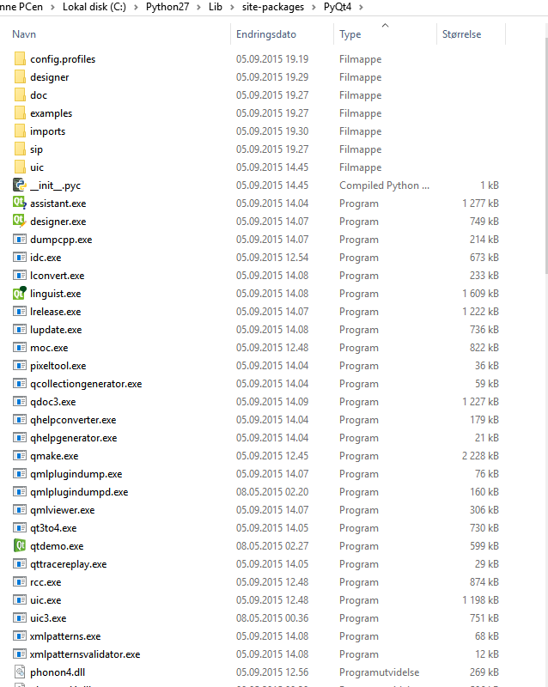

Testing.

We test in Ida Pro python prompt

Commands to see if everything is returned correct.

Python>import PyQt4

Python>from PyQt4 import QtGui, QtCore, Qsci

Python>help('PyQt4')

Help on package PyQt4:

NAME PyQt4

FILE c:\python27\lib\site-packages\pyqt4\__init__.py

DESCRIPTION

# Copyright (c) 2015 Riverbank Computing Limited <info@riverbankcomputing.com>

# This file is part of PyQt4.

Then   
help('PyQt4.QtGui')

A lot is returned.

We can test if QScintilla2 is working with my awesome ida python editor.

Download from my github and test PyQt if QScintilla2 is working.  
<https://github.com/techbliss/Python_editor>

We test to see if the QScintilla2 designer plugin is regonised good in PyQt designer.

Open designer.exe in C:\Python27\Lib\site-packages\PyQt4.

Create new whatever you want and go to Help >> About plugins  
See if the plugin is there with out errors.  
Also it should be in the left panel, where all the rest are.  
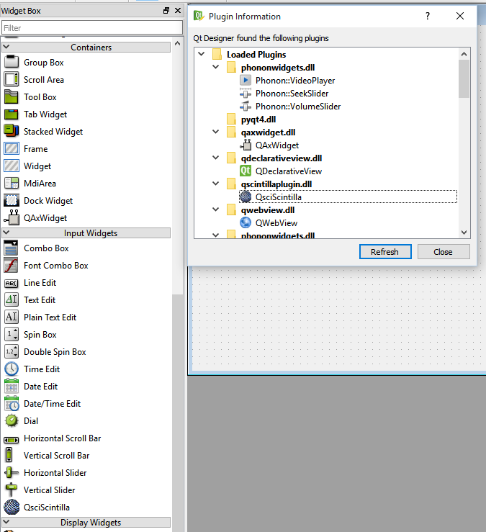

That’s it hope you have enjoyed this “little tut”

Sources @computerline for the tut for PySide and what software to begind with.  
<http://vcyberwarface.blogspot.no/2014/02/compiling-pyside-for-ida-pro-61-on.html>

My Own site and members on Techbliss.org.

<http://www.techbliss.org/>

Riverbank and Qt developers for making this awesome framework.

Hex-rays for making this awesome software.